AI-Assisted Coding Lab Assignment=14.1
Name: G.karthik reddy
Roll no:2403A510f8
Batch no:06
CSE 2nd Year
Task 1 – Portfolio Website Design
You are building a personal portfolio website to showcase your work.
Requirements:
• Create sections for About Me, Projects, and Contact.
• Use AI to:
o Suggest color palettes and typography.
o Create a responsive layout with Grid/Flexbox.
o Add smooth scrolling navigation.
Prompt:
Build a personal portfolio website with these features:
- Sections:
- Use AI to suggest:
  - A modern color palette and typography
  - A responsive layout using Grid/Flexbox
  - Smooth scrolling navigation between sections
Add simple hover effects, a contact form, and make sure the site looks good on both desktop and mobile.
Code Generated:
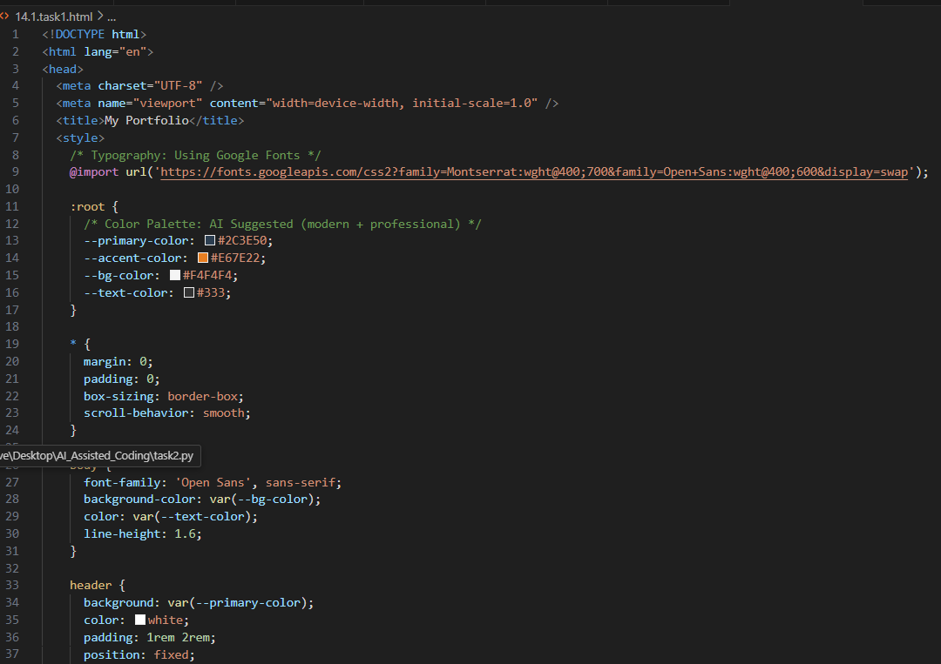
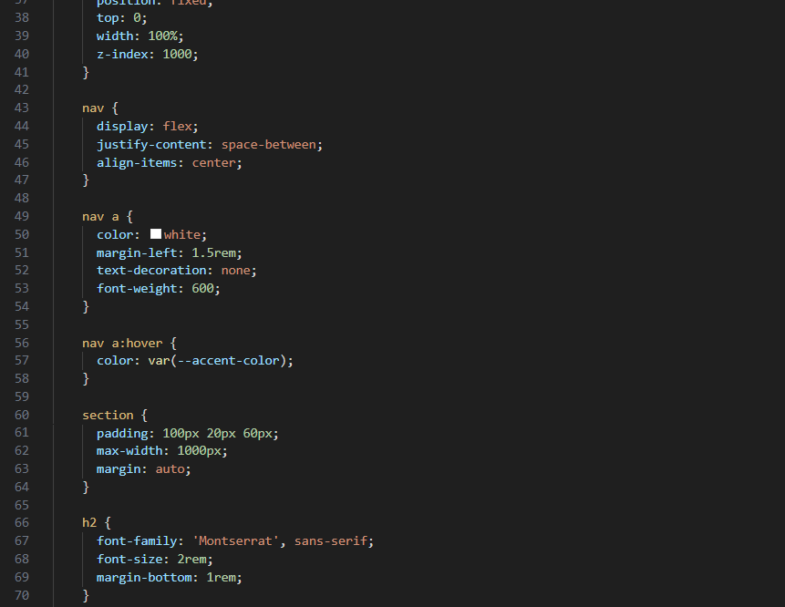
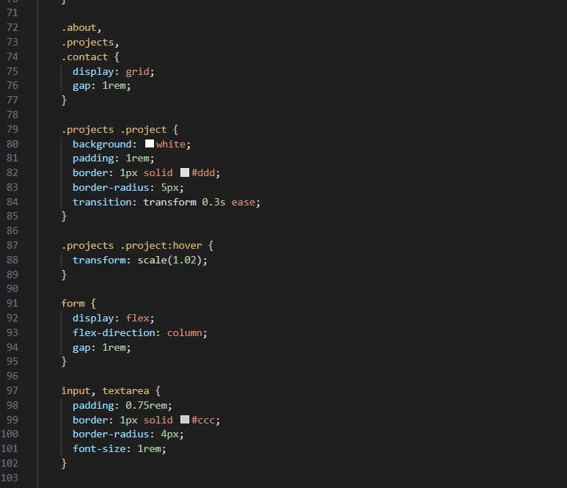
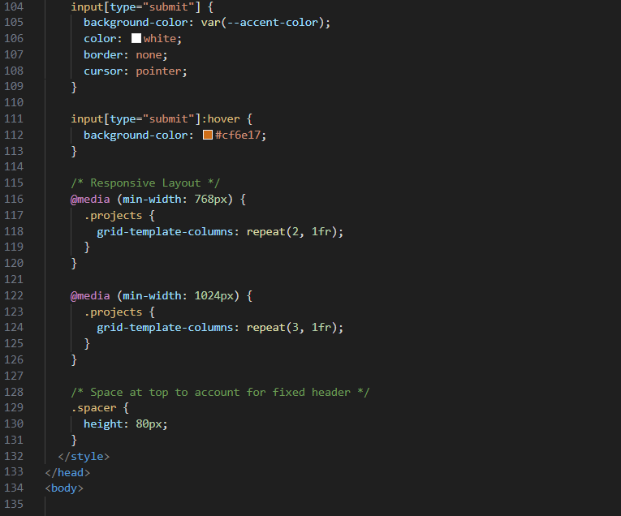
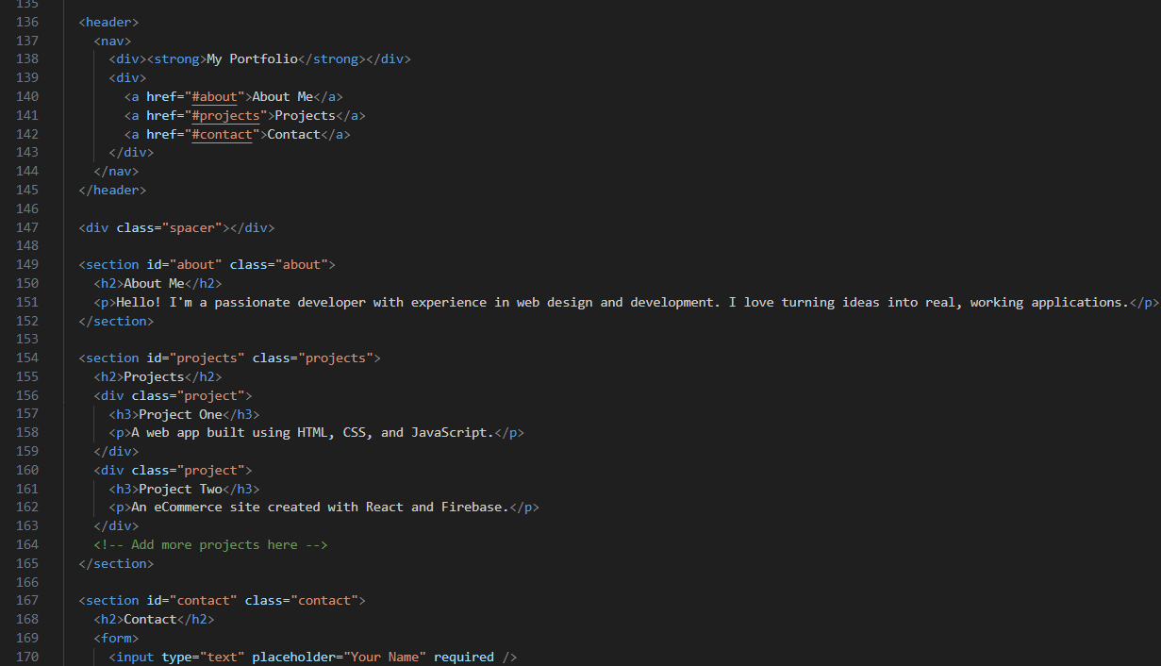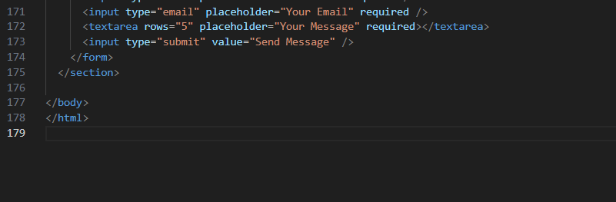
Output:
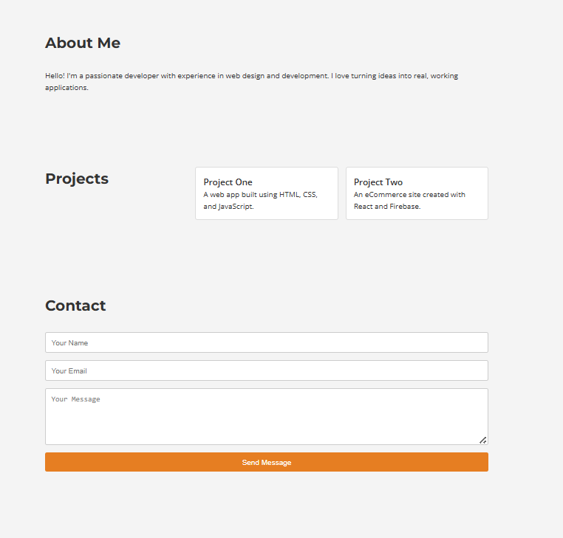
Observation:
1. Section Creation
- About Me, Projects, and Contact sections are clearly defined using <section> elements with IDs for navigation.
✅ 2. AI-Enhanced Design Suggestions
- Color Palette: A clean, professional palette with a dark blue (#2C3E50), accent orange (#E67E22), and a light gray background (#F4F4F4)—suggested for modern portfolios.
- Typography: Google Fonts Montserrat (for headings) and Open Sans (for body text) are used for clean, readable design.
✅ 3. Responsive Layout
- CSS Grid is used for the .projects section.
- Media queries adjust the grid layout for tablets and desktops.
- The layout adapts to different screen sizes, maintaining readability and structure.
✅ 4. Smooth Scrolling Navigation
- scroll-behavior: smooth is applied globally using the * selector.
- The nav links use anchor tags (href="#section-id") to allow smooth transitions when clicked.
✅ 5. Flexbox for Navigation
- Flexbox is used in the nav element to align the brand title and navigation links horizontally and responsively.
Task 2 – Online Store Product Page
Design a product display page for an online store.
Requirements:
• Display product image, title, price, and "Add to Cart" button.
• Use AI to:
o Style with BEM methodology.
o Make layout responsive.
o Add hover effects and "Add to Cart" alert
Prompt
Design a responsive product display page for an online store.
Requirements:
- Show product image, title, price, and an "Add to Cart" button.
- Use AI to:
  - Apply BEM methodology for CSS class naming.
  - Make layout responsive with Flexbox/Grid.
  - Add hover effects and show an alert when "Add to Cart" is clicked.
Code Generated:
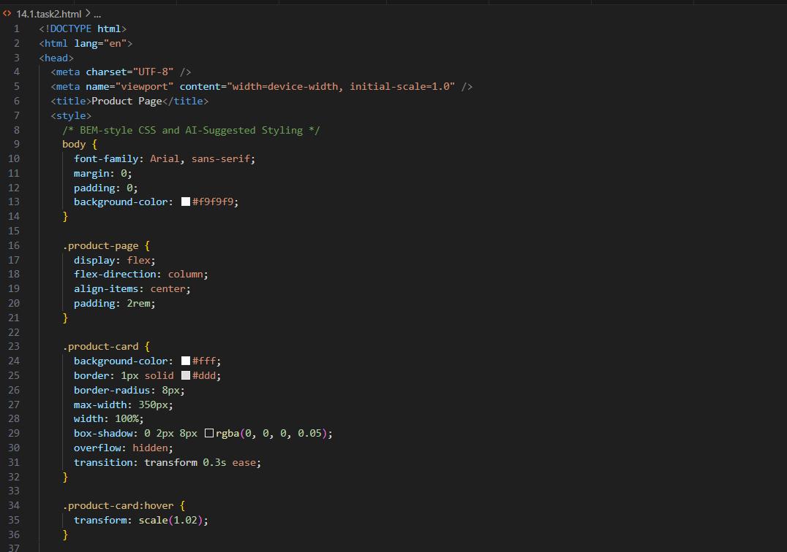
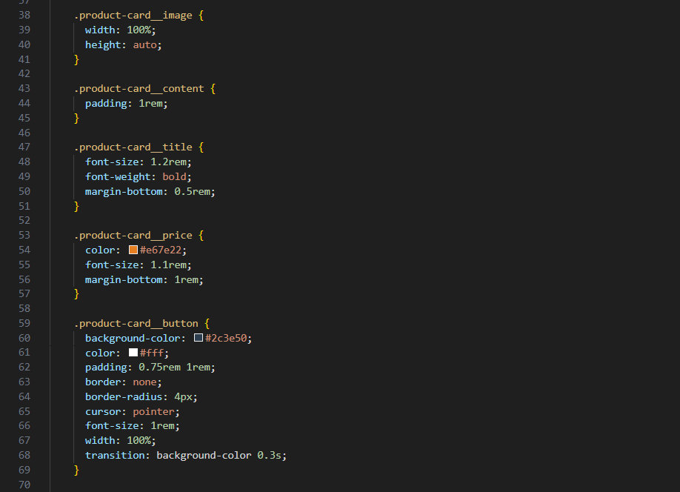
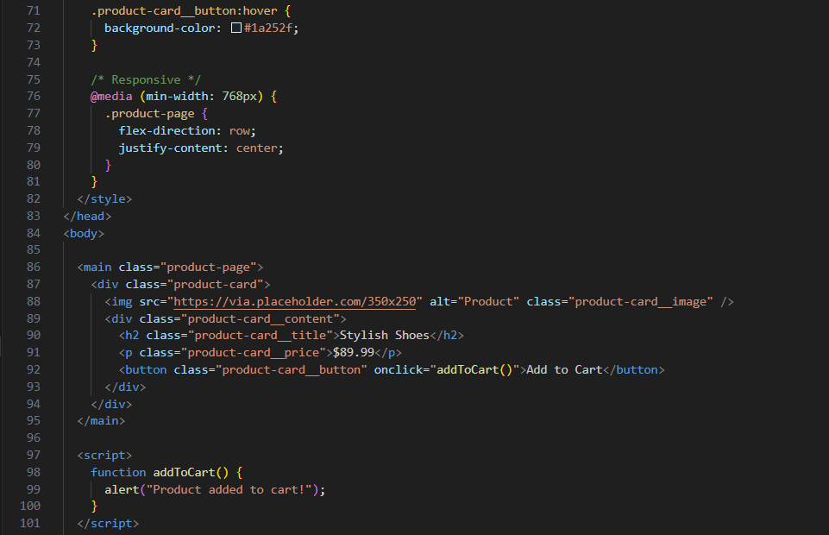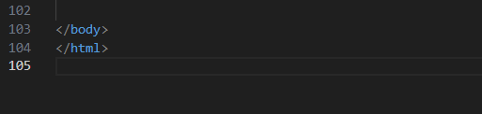
Output:
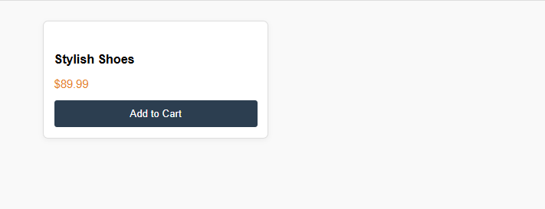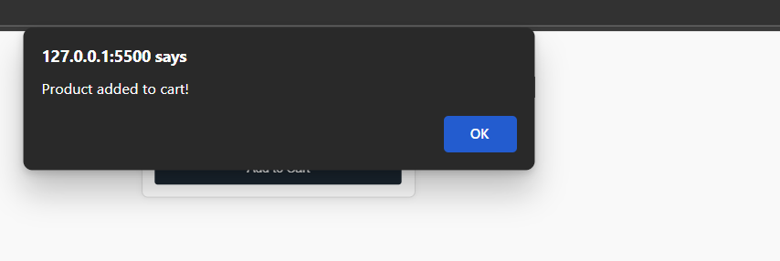
Observation:
Required Elements Present
- Shows product image, title, price, and Add to Cart button.
✅ 2. BEM Methodology Used
- Class names follow BEM (Block__Element format), e.g., product-card__title, product-card__button.
✅ 3. Responsive Layout
- Mobile-first design with Flexbox.
- Switches to horizontal layout on wider screens (@media breakpoint at 768px).
✅ 4. Interactivity
- Hover effect on the card (transform: scale(1.02)).
- Button hover changes background.
- Clicking "Add to Cart" triggers a simple JavaScript alert.
Task 3 – Event Registration Form
Build an event registration form for a conference.
Requirements:
• Collect name, email, phone number, and session selection.
• Use AI to:
o Add form validation with JavaScript.
o Make the form accessible with labels and ARIA.
o Style with a professional look.
Prompt:
Create an event registration form for a conference.
Requirements:
- Collect: Name, Email, Phone Number, and Session Selection
- Use AI to:
  - Add JavaScript form validation
  - Ensure accessibility with proper labels and ARIA attributes
  - Apply professional CSS styling
Code Generated:
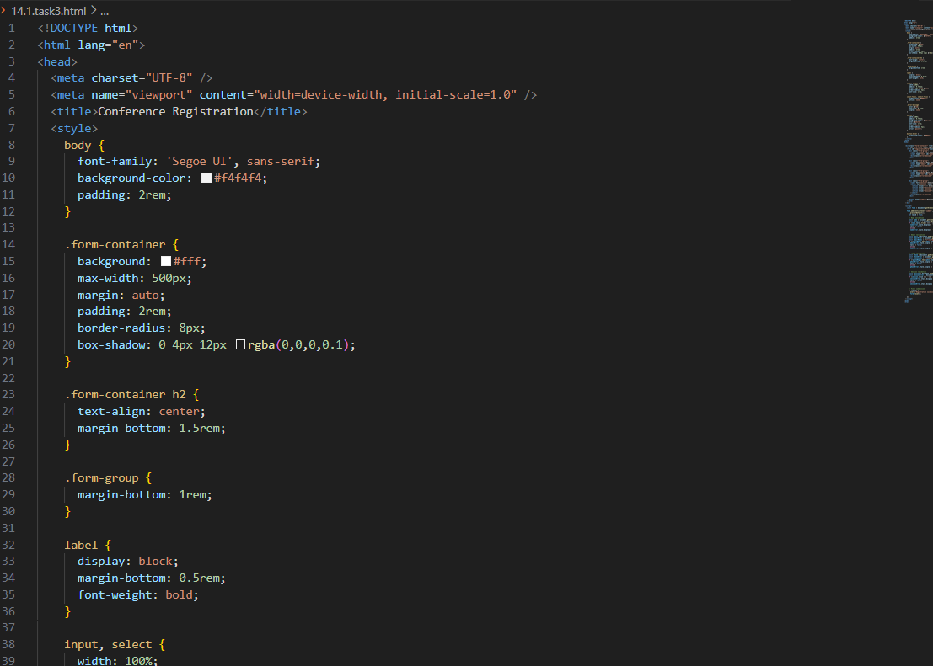
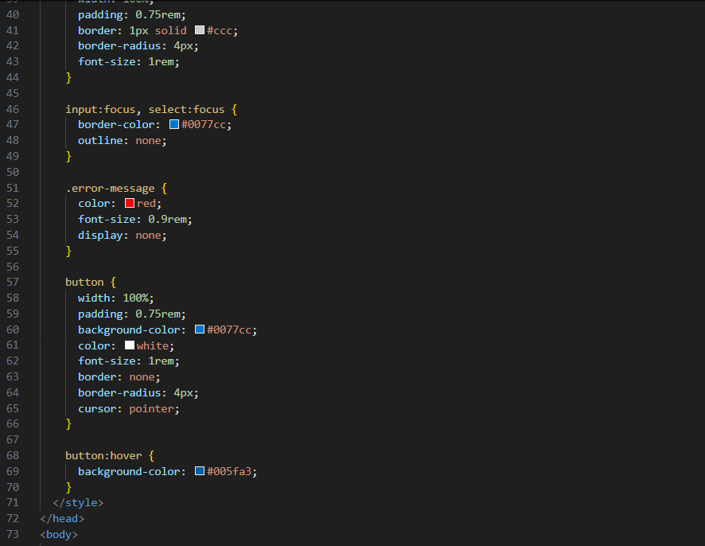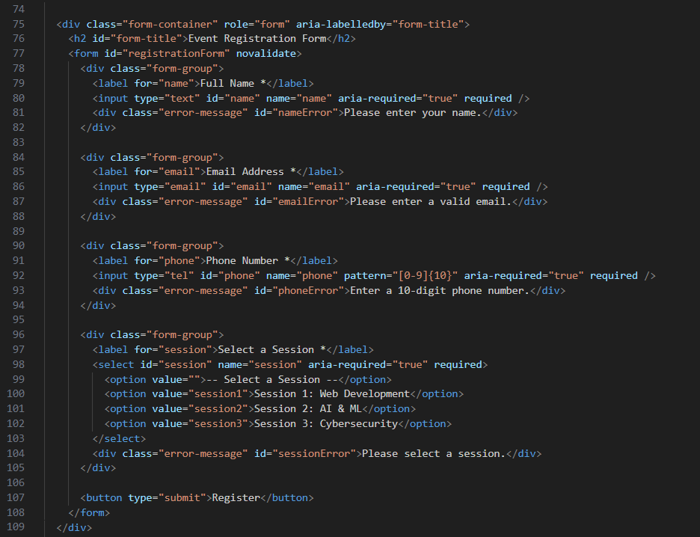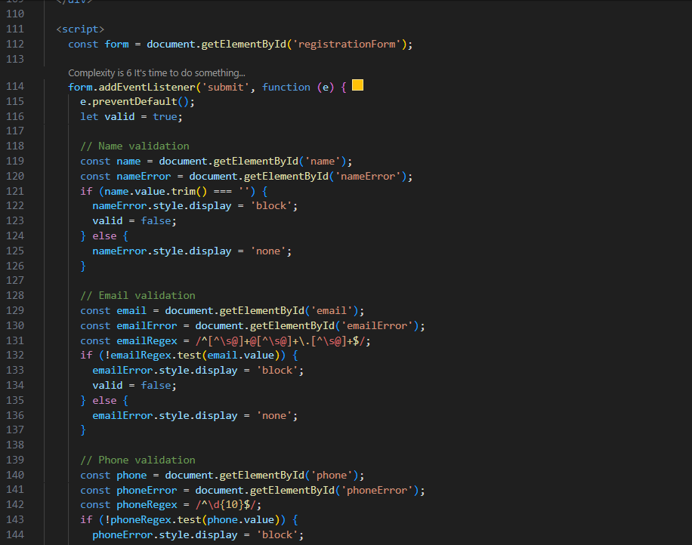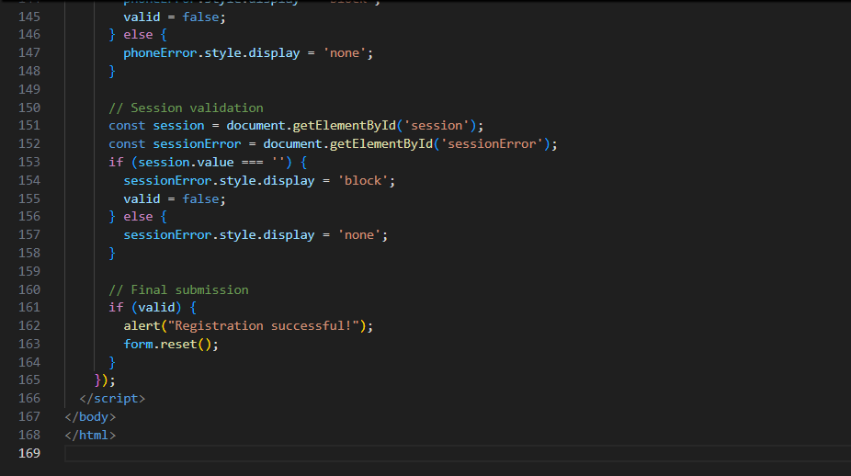
Output:
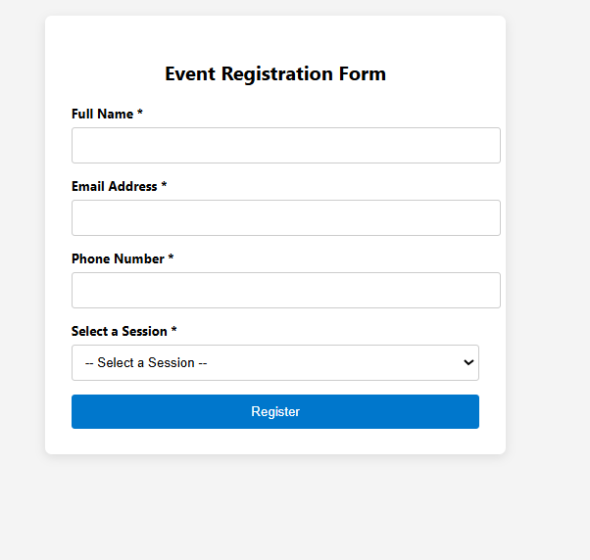

Observation:
1. Form Requirements Met
- Captures: Name, Email, Phone, Session Selection using input and select fields.
- Each input has a <label> for accessibility and ARIA roles where applicable.
2. Form Validation with JavaScript
- Validates all fields:
  - Name: not empty
  - Email: valid format
  - Phone: 10-digit number
  - Session: option selected
- Shows error messages for invalid input.
- Displays alert("Registration successful!") on valid submit.
3. Accessibility Features
- Labels are correctly linked to inputs via for and id.
- ARIA attributes like aria-required and aria-labelledby used.
- role="form" used for screen readers.
4. Professional Styling
- Clean, modern UI with spacing, borders, shadows, and focus states.
- Uses responsive, accessible input styles and button hover effect.
Task Description #4 (Data – Fetch API & Render List with
Loading/Error States)
• Task: Fetch JSON from an API and render items to the DOM
with loading and error UI.
• Instructions:
o Ask AI to write fetch() logic, create DOM nodes safely,
and add skeleton/loading text.
Prompt
Write code to fetch JSON data from an API and render a list of items to the DOM.
Use AI to:
- Write clean fetch() logic with proper error handling
- Create DOM elements safely
- Show loading text or skeleton UI while data is loading
- Show an error message if fetch fails
Code Generated:
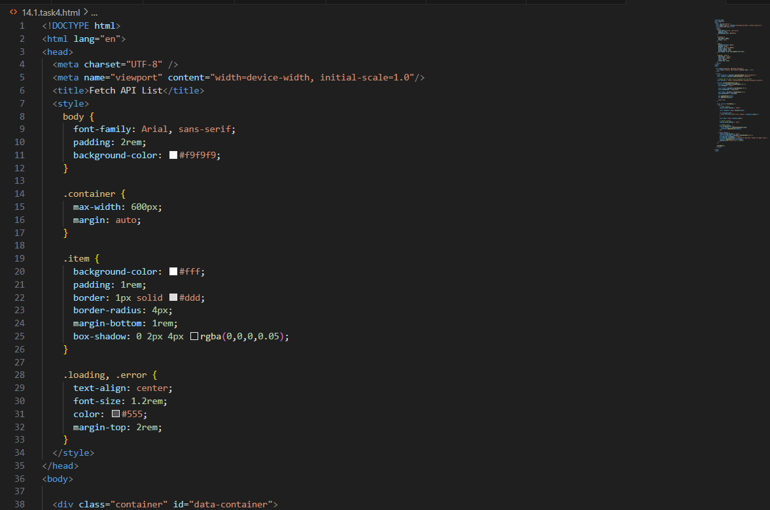
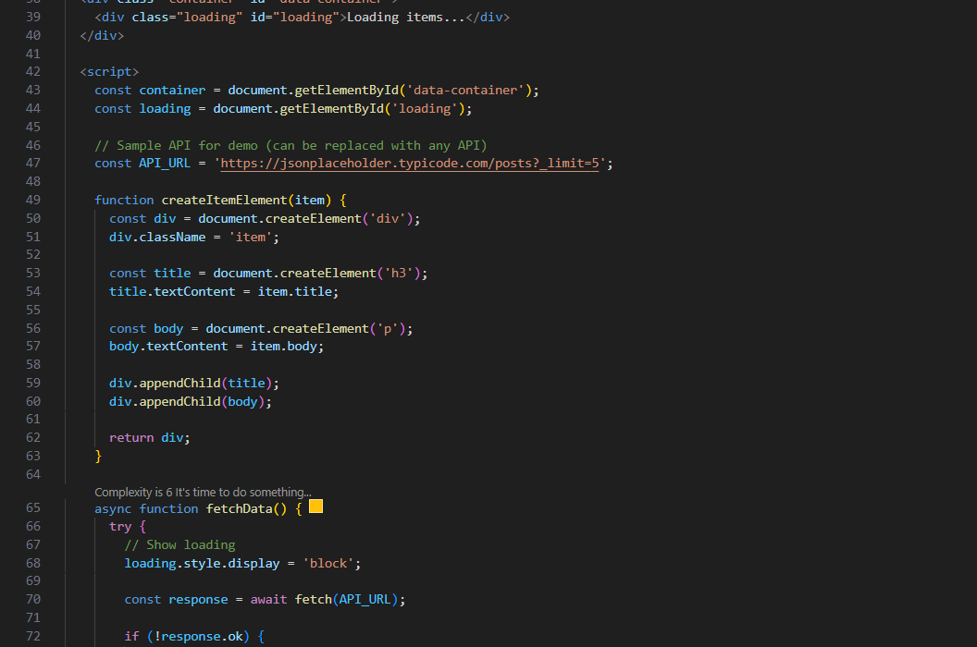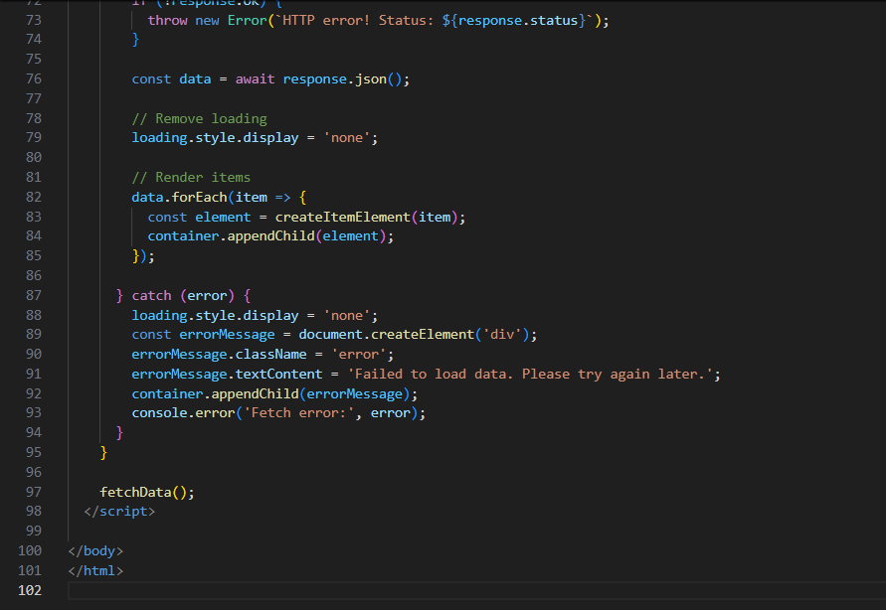
Output:
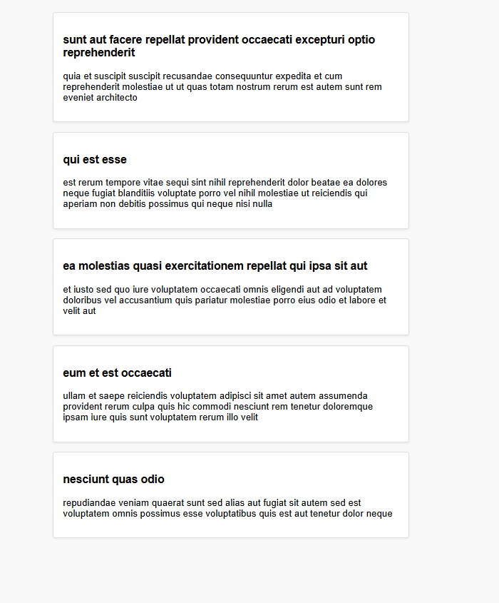
Observation:
1. Fetch JSON Data
- Uses fetch() to get sample JSON data from jsonplaceholder.typicode.com (a placeholder public API).
- You can replace the URL with any other API that returns JSON.
✅ 2. Loading UI
- Shows "Loading items..." text while the data is being fetched.
- Hidden after data is successfully loaded or an error occurs.
✅ 3. Safe DOM Creation
- All DOM nodes (title, paragraph) are created using document.createElement, ensuring security (avoids innerHTML).
- Elements are appended cleanly into a container.
✅ 4. Error Handling
- Uses try...catch block to catch fetch or parsing errors.
- Displays a user-friendly error message in the DOM if the fetch fails.
✅ 5. UI Styling
- Clean, card-style layout for items.
- Text-centered loading and error messages with minimal styling.

